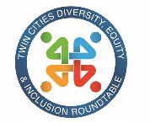
TCDEIR April Member Meeting – NOTES (what could be captured)
April 14, 2022
~60 attendees

Overview (scroll to see more details and notes below)
- New TCDEIR website!!! https://www.tcdeir.com/
- A survey is coming. Your voice matters. We’ve heard more need for in-person meetings.
- Next session – June 9 hybrid in-person session. Kevin Lindsey at MN Humanities session.
- August is our Symposium (we do this every other year). Hosted in-person (if all goes well at Land O’Lakes)

5 things to do to support (see more in notes)
- Understand if you have operations outside of MN.
- Develop policies and develop communications to let them know you projected and safe within the workplace.
- EAP – have you figured out if they are LGBTQ+ Friendly?
- Pronouns, have benefit policies that all support for hormones, and training your team members.
- Be bold! Make press releases.

6 Building Blocks (see more in notes)
- Gender is a social construct
- 35% GenZ knows someone who personally uses gender-neutral pronouns
- Recognize gender norms in the workplace such as gender apprenticeship
- As an ally – be aware if someone is coaching someone into a gender role (if you dress like this, talk like this, etc)
- Pronouns are not “preferred” we don’t call people out on their pronouns.
- Believe people when they tell you who they are.

Resources
Ellie Krug’s handout: https://docs.google.com/document/d/1hj-ykXqBHYw4nJ0BP6xZuIo6OCCZ5GWguoesKLymoU0/edit
Movement Advancement Project | (lgbtmap.org)
WPATH World Professional Association for Transgender Health

Welcome from host, Sonos, Shamayne
Sonos – play in the audio space. Work to create a magical multi-room on an open platform. Share love of music and premium products. Mission to inspire the world to listen better.
What make Sonos – Sonos? 1) ease of experience 2) amazing high quality sound 3) premium design

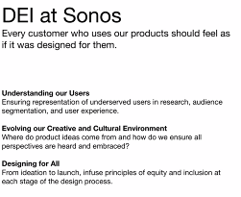

TCDEIR April Member Meeting: April 14th from 8:30-10:00 am with an optional post discussion from 10-10:30 am.
Sonos will be our Sponsor for the session: "Transgender and Nonbinary: Gender Variance in the Workplace".

Welcome, Tonya
Tonya: Workplaces are encountering more and more individuals that identify as transgender and non-binary. Hear from Nick and former TCDEIR exec member Ellie.

Organizations and workplaces are encountering more and more team members who identify as transgender or nonbinary. Join national trainers and speakers Nick Alm and Ellie Krug as they break down the basics of gender identity, discuss challenges that trans and nonbinary people face in the workplace, and how employers can design supportive and welcoming workspaces.

Announcing TCEDIR website, Jenna
https://www.tcdeir.com/
Scroll down – you’ll see the exec board & a contact list. Check out links at the top: About > Events > Membership 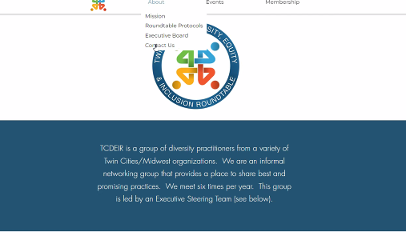

Introduction to speakers, Philomena
THANK YOU Jenna for your creativity. We are a 25 year group and now have a website.

Ellie Krug, Human Works (and previous TCDEIR exec member)
Nick – with Mossier. He did a session with Land O Lakes session with TA team for LGBTA candidate awareness / understanding.
Link to additional details:

There is a lot happening in the U.S.
Discuss ideas you can do to support.

Story from Ellie regarding North Carolina legislature, transgender can only use bathroom for the gender assigned at birth Example, Ellie would have to use Men’s bathroom.
- Large uproar. Large events cancelled.
- When Target Corp issues public statement – for all of its stores across America, they will allow people to use bathrooms related to gender identity.
- That announcement provided great waves. Boycotts to happen and LGBTQ gave thumbs up.
- Ellie penned a piece that Target was brave and willing to protect her and her community. She gave a one page thank you to Target and stood in skyway handing thank you notes to 150 people.
- This was a bold statement! Target is doing fine in America.
- Six years later – not only North Carolina, across America, multiple states, Transgender people are being targeted.
- There are 14 states prohibiting transgender (especially girls) not allowed to participate in sports. Alabama passed law that trans kids need to use locker room and bathrooms based on gender assigned at birth and a 10 year prison sentence to treat anyone younger than 19.
- Question – where is the outrage? Can you imagine if kids that are diabetics that cannot participate in sports?

5 things for you to support
- Understand if you have operations outside of MN. Odds are, those are in states where non-binary and trans people don’t have legal rights in housing, buying car insurance. Please understand that. This is all about fear.
  - 20% of GenZ identifies a non-binary and trans. We don’t truly know the number.

- Develop policies and develop communications to let them know you projected and safe within the workplace. You may have no team members, even if you don’t you may have team members with family members. When a communication goes out – this helps them.

- EAP – have you figured out if they are LGBTQ+ Friendly? Are they qualified to counsel? Do they have an understanding of how to counsel? These orgs may be in states that do not support. Some therapeutic professionals have agendas and if they work with you long enough you’ll be fixed. You’ll be amazed at the numbers of how many people treat trans/non-binary and then few people that receive the training to support this community.

- Pronouns, have benefit policies that all support for hormones, and training your team members.

- Be bold! Make press releases. Ellie will shop at Target of the res of her life – a loyal customer forever. One resource to find who has laws / who proect: movmentadvancementproject – Map

Ellie shared Nick’s bio. Nick shared their story
- SNL skit – they moderated the fashion show at age 10. Wore borrowed dress from mom, and narrated.
- Nick identifies as non-binary.
- When Nick went to business school, needed to stuff all that down. For Nick, gender is a knowing. A deeply held believe. Still on this journey.

Investigating Gender, Nick Alm with Mossier
Goal – to get you curious.
There is so much being done to non-binary people right now. Many people are disconnected from this conversation.

First – foundation to get clear on
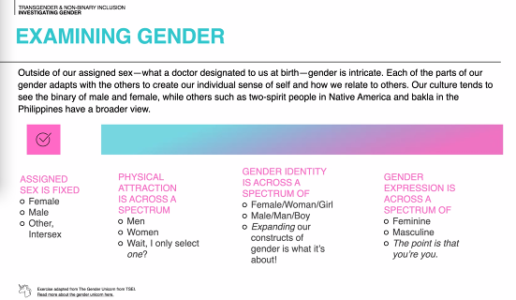

Biggest challenge to break down – “perform gender”
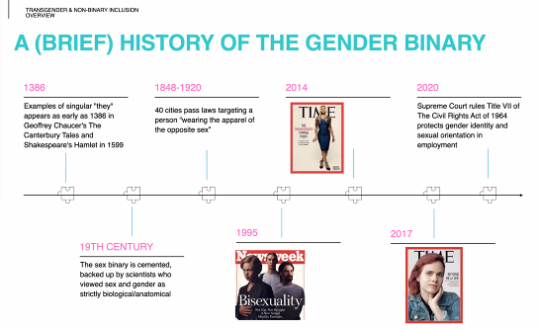

- Legal protections only cover those that fit one box and move to another box. There are challenges for people to get the surgery, costs associated with hormones, etc.
- So many young people stepping in now.
- It hasn’t even been 2 years that the Supreme Court rules tTitle VII that gender identiy and sexual orientation in employment is covered.

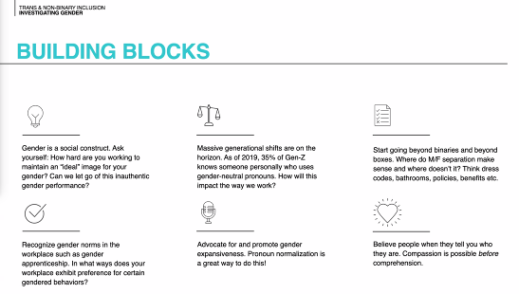

We are actively, collectively, making decisions of what it means to be a man/women/non-binary. It is cultural.
Do bathrooms, clothes, etc really need to be gendered? How much matters for masculine vs feminine presentation styles?
As an ally – be aware if someone is coaching someone into a gender role (if you dress like this, talk like this, etc)

Questions & Answers
- One question that came through: last year we implemented a pronoun email signature policy. It is not something that is required. We received feedback from both women and trans/non-binary employees that they didn't want to add their pronouns to their email as they didn't want to identify for worries about retaliation. Shortly after, we had a lot of men jump on that train stating having the policy was forcing people to out themselves. Any input on how to bridge this gap
- Every time a policy is created, the policy may need to be updated in a year. That is the gender issue. It is an ever evolving social construct. Not a fan to say you must put pronouns. Those that add their pronouns because they want to and understand the meaning.

- We are wondering if we should ask staff to share if they are part of LGBQIA community when we ask staff to identify race. Similar to when is the best time to ask for pronouns, we can't decide if/ when to ask. We would like to know so that we can track how we do with retention, etc. similar to how we track BIPOC staff. Thoughts?
  - X

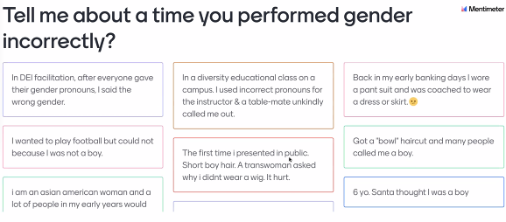

Common themes
- This work is evolving and we are learning together.
- There are “rules” and we are breaking the rules.
- Bravery & fitting in – also brave story shared

Question – incorporate and invite immigrant communities?
- There are few spaces that young adults can go.
- There is someone trying to get a community center that will provide support.

Thank you Ellie and Nick. For educating us! Sonos and Shamayne – thank you! Thankful for your hosting. Jenna – thank you for bringing us into 2022!! As Jenna said, we’ll continue to evolve.

A survey is coming.

Next session – June 9 hybrid in-person session. Kevin Lindsey at MN Humanities session.
August is our Symposium (we do this every other year). Hosted in-person (if all goes well at Land O’Lakes)

