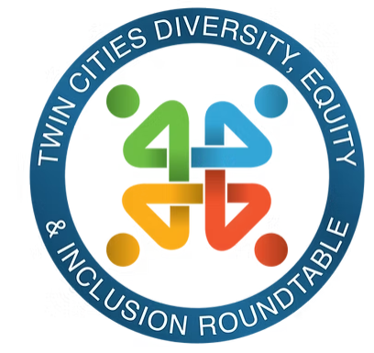
TCDEIR Member Meeting
October 16, 2025

Thank you science museum and steering community!
Symposium will be annual now! We made hygiene kits. Philomena gave one and it touched both of their hearts.

Science Museum is part of science education “SEEDE” That has 4 centers.

Center for Equity & Systems Change (CFESC) Work with a variety of public private and institutions with a focus on this.

KAYSC program pathway and CFESC both support workforce pathways for 21st century leadership.

They move groups from good intention to action.

Reach out to CFESC and IDEAL (inclusion, diversity, equity action, learning) to support you in this work!

Thinking and Systems book, shared the hula hoop exercise. WOW! What happens when asked to lower, it goes up vs down. Similar to the system. It’s what the system does, not the intention, not what we want it to do!!

Systems are not always obvious and can conflict with our beliefs on what we think it should do.

Systems Theory

We have elements, what we notice first. Often that isn’t what is a full description of the elements. There are seen and unseen in the system. Ask of this is interconnected. The rules of no talking in the exercise decrease the interconnectedness.

Group Discussion:
“Warm Data” by Nora Buteson
- When we pick a “reason” and try to improve an area, yet it doesn’t work in an area. Through this we lost our sense of community. Is also how forests works. Moving together, interconnectedness. We discount warm data.

- Group discussion ranged from emotions, trying to understand, seeing similarities to our current system and reactions.

Systems Change
We try to change one element and often that doesn’t work. “swap out people “ and system still doesn’t work. Swapping out bad apples…yet system still doesn’t work.

Systems are not sums of their parts. It’s determined of how we work together!
Example, this is the group I get to work with, how can I get my work done with this group? It’s about our interconnectedness!

What are better ways to change the system?
It’s about changing the paradigms in how the world works!! This is the most powerful and fastest way to change a system. It’s not blame, shift to it’s all of us together and how we can better relate to each other!!

6 Key Factors of organizational change
1. Believe in the possibility of change
2. Critical mass of individuals to hold vision and institutional memory.
3. Awareness of power dimensions and one’s spheres of influence.
4. Risk taking and experimentation that can inform/support shifts in practice.
5. Foster relationships to provide support and build a sense of connectedness
6. Reflection for shared learning, agility to be responsive abs effectively mobilize.

Items to keep in mind: trauma that people feel, fear people feel need to be worked on as an individual.

How is the system able to set up so everyone can thrive?

